SAD Phase 3

|  |  |
| --- | --- |
| **NAME** | **MATRIC NO.** |
| Alaa Eddin Hussain Albashir | A23CS0008 |
| Justin Fauzadani Azka | A23CS4012 |
| Knan Fadi Dawarh | A23CS4013 |
| Asqy Tarmidzy | A23CS4021 |

Prototype link: <https://www.figma.com/design/geSC2JE6QM3eTOlvOvYoYz/SAD-Project?node-id=0-1&t=83A56sAOT47dH9Vu-1>

Prototype video link:

https://www.youtube.com/watch?v=Z__9xQQMf24

GitHub link:

https://github.com/KINANFADI/SAD-phase-3

Introduction

For a manufacturing company to be successful, managing its inventory well is very crucial. Should a company have poor inventory control there are a number of problems it may face. These include inaccurate stock levels, production schedules that are disrupted by shortages and surpluses, high costs of operations as well as inability to meet customer demands in time. Consequently, the project for improving inventory management called Enhanced Inventory Management System (EIMS) was initiated.

**Overview of the Project:**

The Enhanced Inventory Management System (EIMS) project aims to address inefficiencies in the current manual inventory management practices at a manufacturing company. These inefficiencies include inaccuracies in inventory levels, disruptions in production schedules due to stock shortages or excess, increased operational costs, and challenges in meeting customer demand promptly.

**Problem Statement:**

The current inventory management practices rely heavily on manual data entry and paper-based record-keeping, leading to discrepancies between documented and actual inventory levels. This results in frequent stockouts, surplus inventory, production delays, and higher operational expenses. Additionally, the lack of real-time visibility into inventory movements hinders the company's ability to forecast demand accurately and plan production effectively.

**Proposed Solutions:**

The EIMS proposes several key features to mitigate these challenges:

* Real-time inventory tracking to enhance visibility and accuracy.
* Automated reorder points and demand forecasting to optimize inventory levels.
* Supplier management module to improve procurement processes.
* Integration with production planning for seamless workflow coordination.
* Reporting and analysis tools for data-driven decision-making.

### **Benefits**

* Increased accuracy and reduced manual errors.
* Cost efficiency through optimized inventory levels and improved forecasting.
* Enhanced production scheduling and minimized disruptions.
* Improved competitiveness and profitability through efficient inventory management.

By adopting this solution, Manufacture Company can improve operational efficiency, reduce costs, and enhance market competitiveness.

**Current Business Process/Workflow:**

The current workflow involves manual data entry of inventory levels, manual reconciliation of inventory records, and periodic manual generation of inventory reports and order forms. This process is inefficient, prone to errors, and lacks real-time insights.

1. Inventory Tracking and Management

-Manual Data Entry:

Receiving inventory information on paper or in spreadsheets.

Employees, physically present at periodic inventory checks, recount and update inventory levels.

- Physical Records:

Inventory records are maintained in physical logbooks or files.

Discrepancies between recorded inventory and actual inventory happen frequently due to human error.

2. Stock Movement and Control

- Manual Tracking:

Manuscript tracking of the incoming and outgoing movement of inventory items.

Inventory stock movement records are updated manually. This can cause delays and errors. ● Non-Real-Time Insight: △Inventory levels get updated only at periodic intervals. Thus, there is a lack of real-time vision. Inadequate inventory or overstock situations are usually realized when it's too late, result in a possible loss in production or overstock of parts. 3. Order Processing and Replenishment.

Manual Reorder Process: △ The inventory is manually inspected to determine when to reorder. Orders are made based on mathematical calculations and approximate evaluations.

- Lead Time Delays:

Manual tracking leads to delayed reordering.

Late inventory replenishments disrupt production schedules.

4. Production Scheduling

- Disconnected Systems:

Production schedules are prepared in isolation from inventory tracking.

The absence of integration between production planning and inventory management across separate systems results in misalignment

-DELAYED PRODUCTION :

Inventory shortage frequently disrupts the production schedule.

- Too much inventory incurs extra storage costs and may go to waste.

5. Demand Forecasting

- Limited Forecasting Tools: 753

Demand Forecasting is manual and mostly based on historical sales data and gut feeling.

No advanced tools or techniques to predict future demand with accuracy are in place.

- Inaccurate Predictions:

Due to a lack of reliable forecasting, the business fails to set appropriate inventory levels that would allow it to match demand in real-time.

Stock outs or overstock situations regularly occur.

**Logical DFD (AS-IS):**

The AS-IS logical Data Flow Diagram (DFD) illustrates the interactions between the inventory management system and external entities such as suppliers, customers, and production departments. It details the flow of data in the current system, highlighting the inefficiencies in data handling and processing.

### **Systems Analysis:**

**Find out what is done and why it is done, records all events/activities:**

During this phase, we conducted thorough information gathering through surveys and interviews to understand the current inventory management practices. We documented all activities related to inventory handling, from data entry to reporting, and identified the reasons behind existing practices.

**Generate models (diagrams) showing who does what, when?**

We created process models and diagrams to depict the roles and responsibilities in inventory management, mapping out who performs specific tasks and when these tasks are executed.

**Refine your model on requirements, add more details:**

Based on initial findings, we refined our models to include detailed requirements for the EIMS. This involved specifying input sources, processing steps, and output formats for each module within the system.

**Generate a new model showing just what is done (logical model):**

We developed a logical model that streamlined the inventory management process, focusing on automating data entry, enhancing reconciliation processes, and integrating real-time tracking and forecasting capabilities.

**Check your analysis with the users:**

Throughout the analysis phase, we engaged with stakeholders and users to validate our models and requirements. Their feedback helped refine the system design and ensure alignment with operational needs and objectives.

Child update inventory records

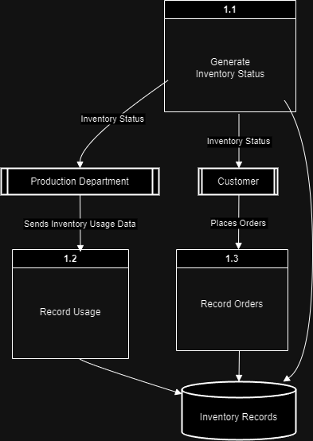

Context diagram (AS-IS)

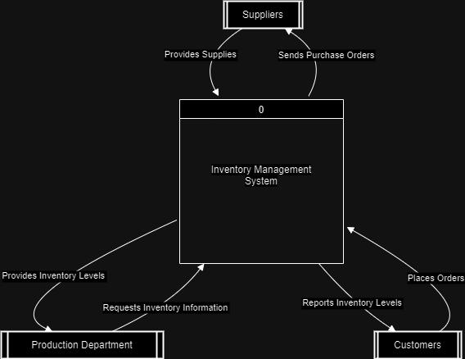

Diagram 0 (AS-IS)

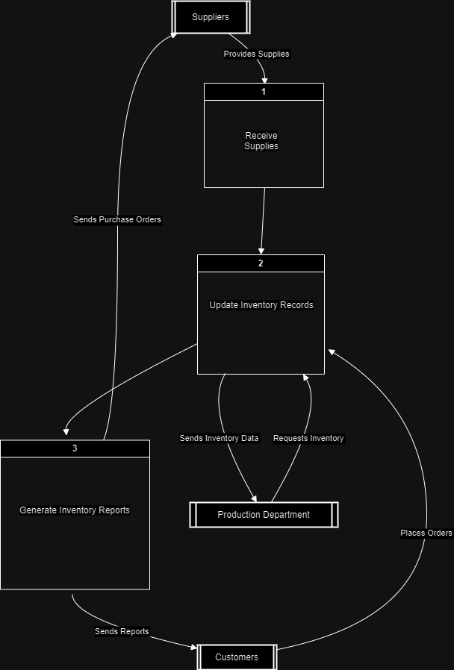

child Generate Inventory Reports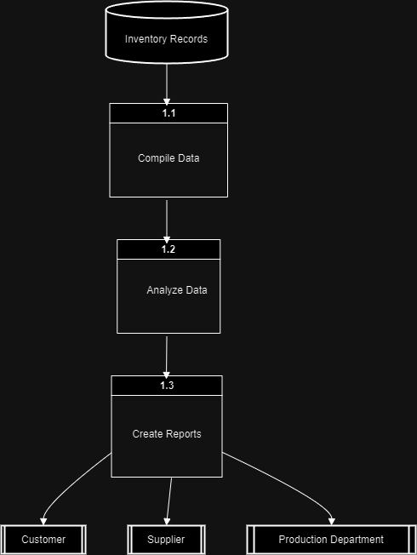

child receive

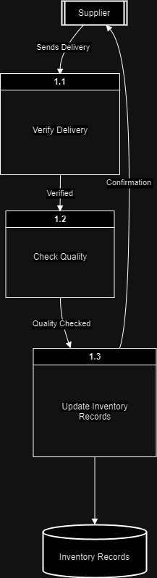

CRUD Matrix (TO-BE)

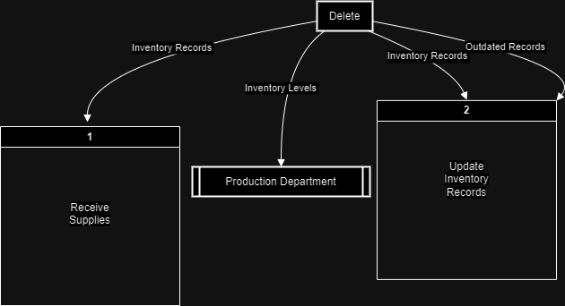

Structure chart

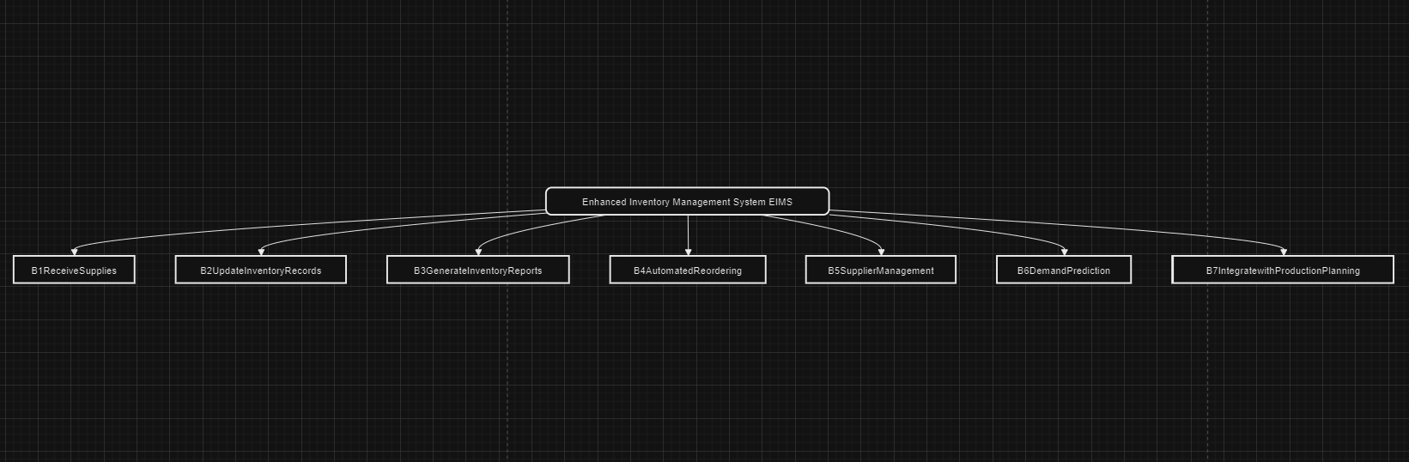

Partitioning Diagram (TO-BE)

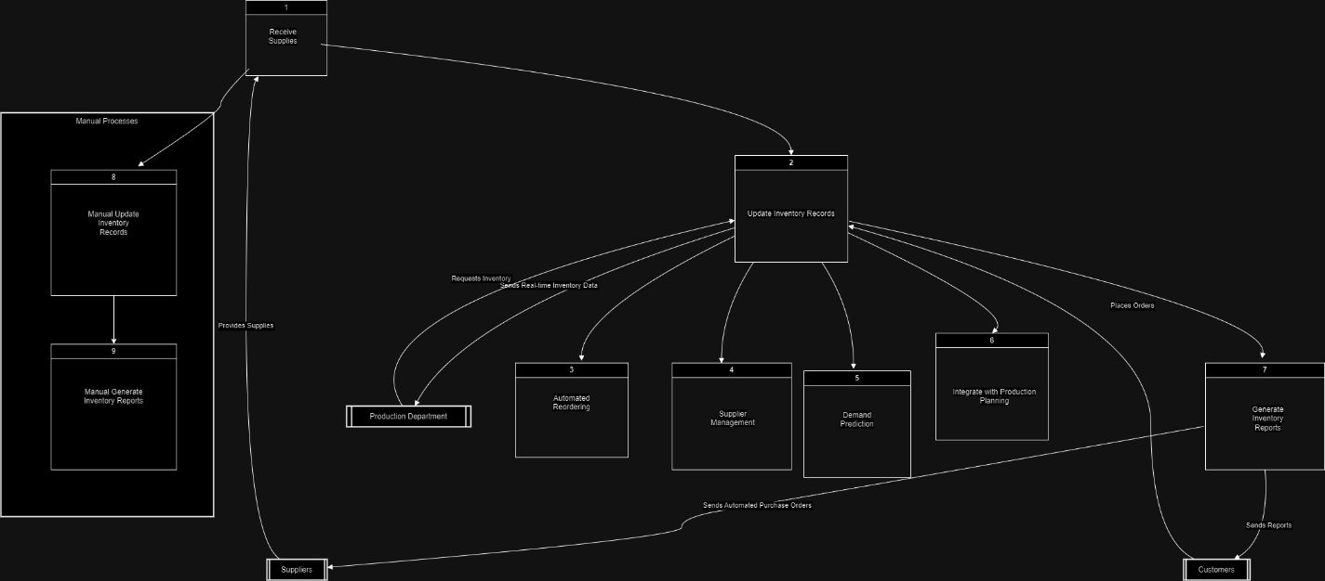

Event table

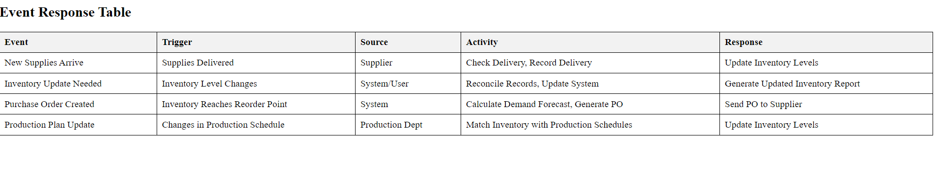

System Architecture

